**Module 1**

* **What is SDLC**

SDLC is a process which defines planning, implementation, testing, documentation and maintenance of software.

Phases of SDLC :-

Requirement Gathering

Analysis

Design

Implementation

Testing

Maintenance

* **What is Software Testing ?**

Software testing is a process to identify correctness completeness and quality of developed product / software.

* **What is SRS ?**

A software requirement specification is complete description of the behaviour system/product to be developed.

Types of requirements :-

Customer requirements

Functional requirements

Non functional requirements

* **What is oops ?**

Oops is object oriented programming which focus on data rather than process.

* **Write basic concepts of oops**

Object

Class

Encapsulation

Inheritance

Polymorphism

Over loading

Over riding

Abstraction

* **What is object ?**

Object is an instance/example for a class. An object represents an individual, entity or a item.

e.g – Apple is an object

* **What is class ?**

Class is blueprint of an object.

A class represents an abstraction of the object.

e.g – Fruit is a class for apple , banana , graps etc.

* **What is encapsulation ?**

In oop encapsulation refers to wrapping up of data into a single unit.

Any external entity can’t access data from outside of a class.

* **What is inheritance ?**

Inheritance refer to obtain a property and behaviour of parent class into the child class.

e.g – Relationship of father and son

Son is child class and father is patent class.

* **What is polymorphism ?**

Poly means many

Morphs means forms

Polymorphism refers as having many forms.

Types of polymorphism

Compile time : Over loading

Run time : Over riding

* **Write SDLC phases with basic introduction.**

SDLC is a structured imposed on the development of a software product that defines the process for planning, implementation, testing, documentation , deployment and maintenance of software.

Phases of SDLC :-

Requirement Gathering : Establised customer needs gathered

Analysis : Model and specify requirements

Design : Model and specify solution

Implementation : Develop the software

Testing : validate product against requirements

Maintenance : Repair defects and add new requirements

* **Explain phases of waterfall Model**

The classical software lifecycle and the software development as a step by step waterfall between the various development phases.

Requirements collection : We need to first collect the requirements of clients.

Analysis : Then we will analysis the need of requirements and will go on next phase

Design : In this phase we will do plan to design the products as per customer needs and finalize the design of the product.

Implementation : Now we will make products as per requirements and strategy.

Testing : We will do testing on developed product and find defects and fixed it for final use.

Maitenance : In this phase we will maintain the product and add new product as per requirements.

In this waterfall model we will go onwards we cant move backwards and change anything. This is traditional method of testing.

* **Write phases of spiral model.**

Spiral model is widely used in software industry.

Phases

Planning : Determine the objective , alternative and constraints of the requirements.

Risk Analysis : Analysis the risk of the product and resolution we will do testing on planning . Risk analysis is must in every project as it will hamper the cost and duration of project.

Engineering : We will develop the product as per requirements for end use.

Customer Evalution : Now we will testing the product for final customer use.

In this model we will go back in any phase and do changes or addition in every phase as per need.

* **What is agile methodology ?**

Agile model is combination of iterative and incremental process models with focus on process adaptability and customer satisfaction of working software.

* **Write agile manifesto principles**

Individuals and interactions - in agile development self organization and motivation are important as are interaction like pair programming.

Working software – Demo working software is considered the best means of communication.

Customer collaboration – continues customer interaction is very important to get proper product.

Responding to change – Agile development is focused on quick responses to change and continuous development.

* **• Explain working methodology of agile model and also write pros and cons.**

Agile model is combination of iterative and incremental process models with focus on process adaptability and customer satisfaction of working software.

**Pros**

Is a very realistic approach to software development

Promotes teamwork and cross training.

Functionality can be developed rapidly and demonstrated.

Resource requirements are minimum.

Suitable for fixed or changing requirements

Delivers early partial working solutions.

Good model for environments that change steadily.

Minimal rules, documentation easily employed.

Enables concurrent development and delivery within an overall planned context.

Little or no planning required

Easy to manage

Gives flexibility to developers

**Cons**

Not suitable for handling complex dependencies.

More risk of sustainability, maintainability and extensibility.

An overall plan, an agile leader and agile PM practice is a must without which it will not

work.

Strict delivery management dictates the scope, functionality to be delivered, and adjustments

to meet the deadlines.

Depends heavily on customer interaction, so if customer is not clear, team can be driven in

the wrong direction.

There is very high individual dependency, since there is minimum documentation generated.

Transfer of technology to new team members may be quite challenging due to lack of

* **Usecase of online book shopping**
* 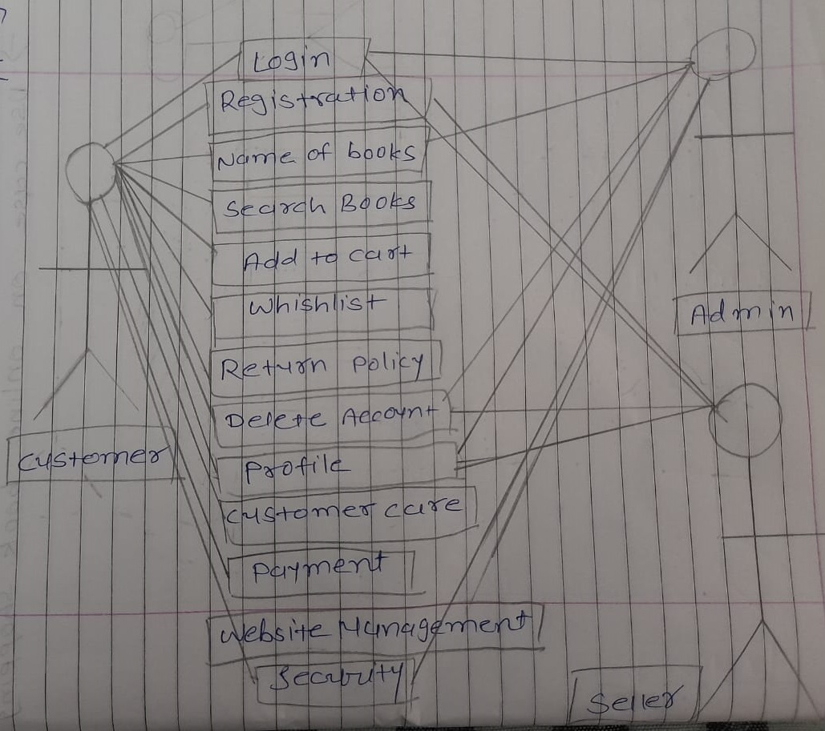
* **Use case of online bill payment system (Paytm)**

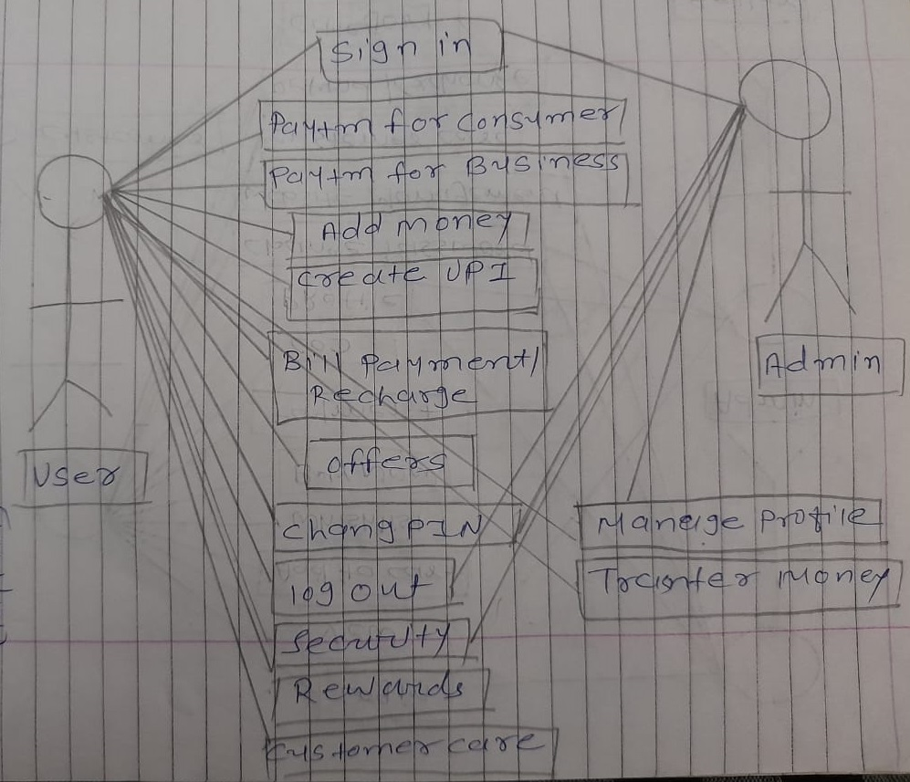

* **Use case of online shopping product using COD**

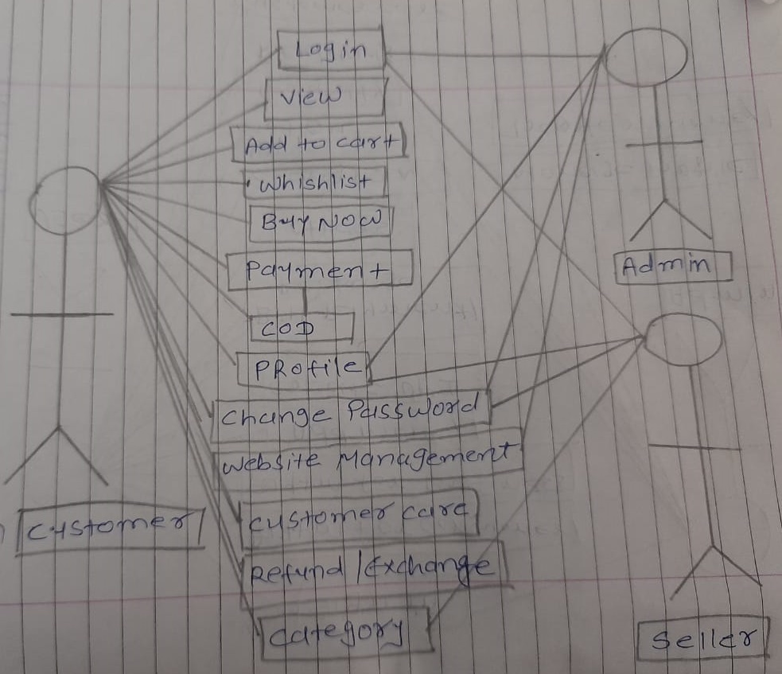

* Use case on online shopping product using payment gateway.

